2) create a VPC network to communicate between 2 VM instances present in different networks.

ANSWER: Step1: Create VPC network1 and add its subnet as asia-south1 ,and create another network2 add subnet Europe west4 , Add subnet to VPC network2 as EuropeWest4

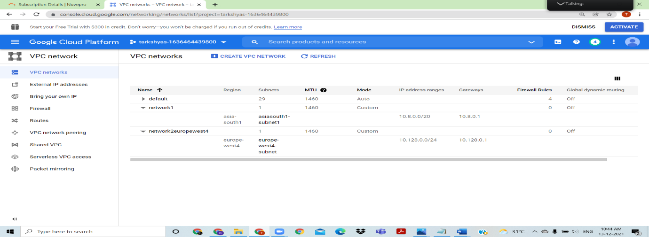

Created two VPC networks

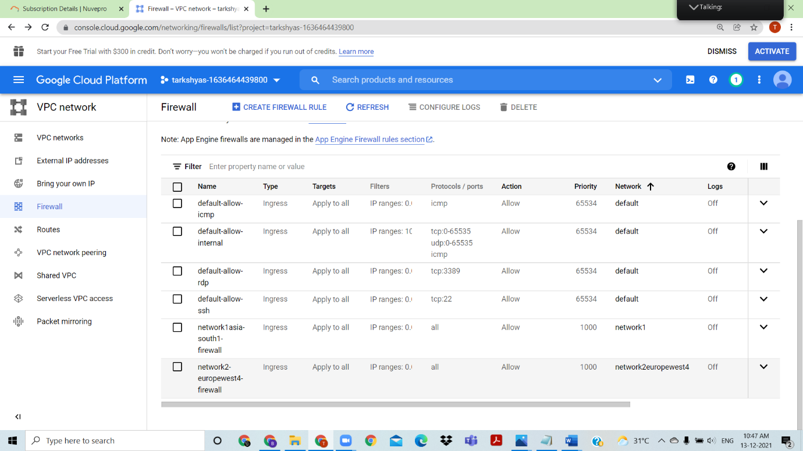

Firewall created for both networks.

In Hybrid Connectivity ,create classic VPN connection

Select classic VPN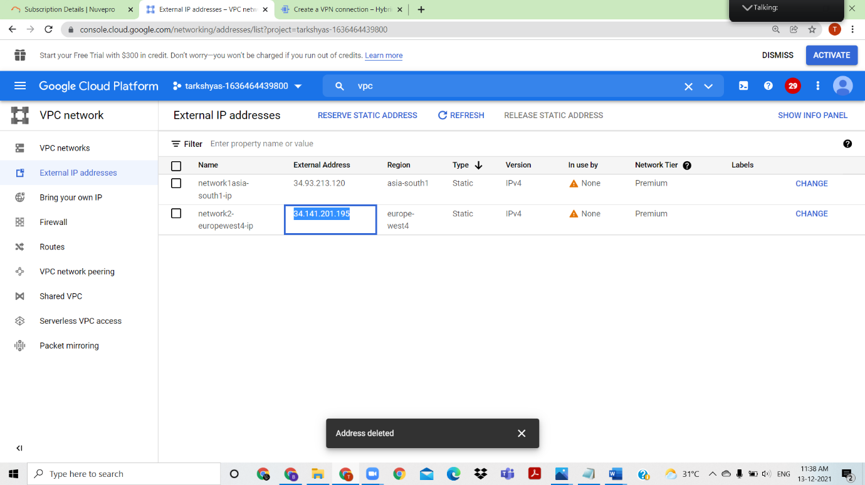

Use the external ip of network2 to do next step

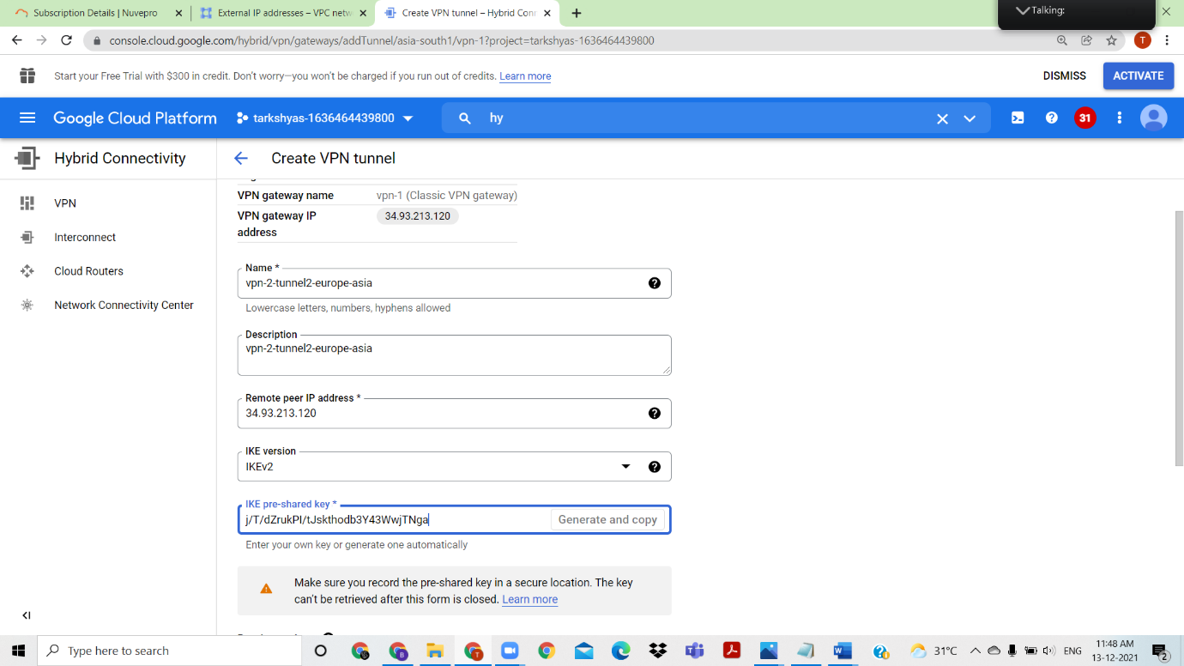

Generate key and do the same step to create tunnelling for both networks.

Create the VM instance for network1 in Asia-south1

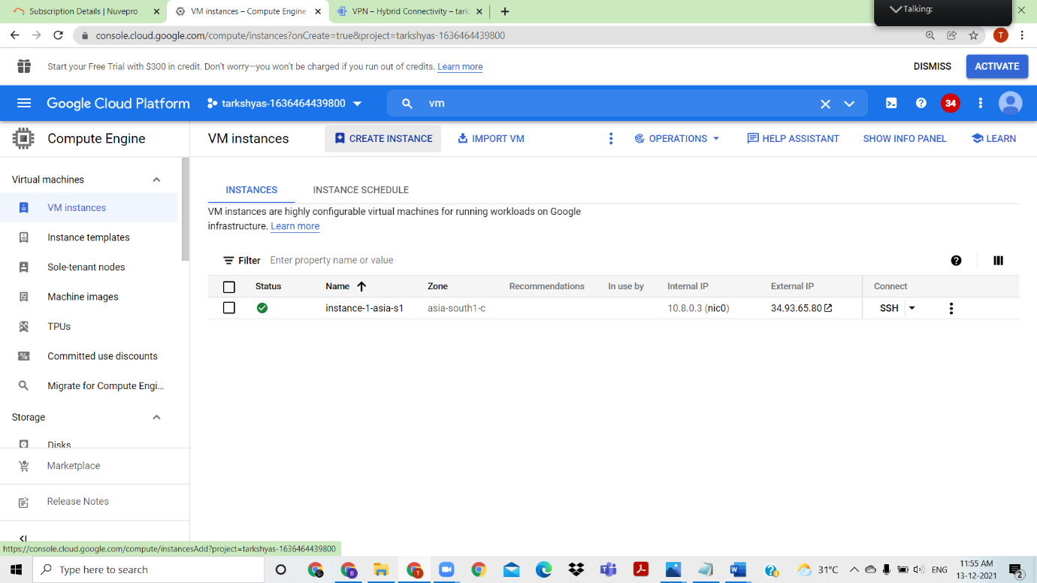

Network1 vm instance created

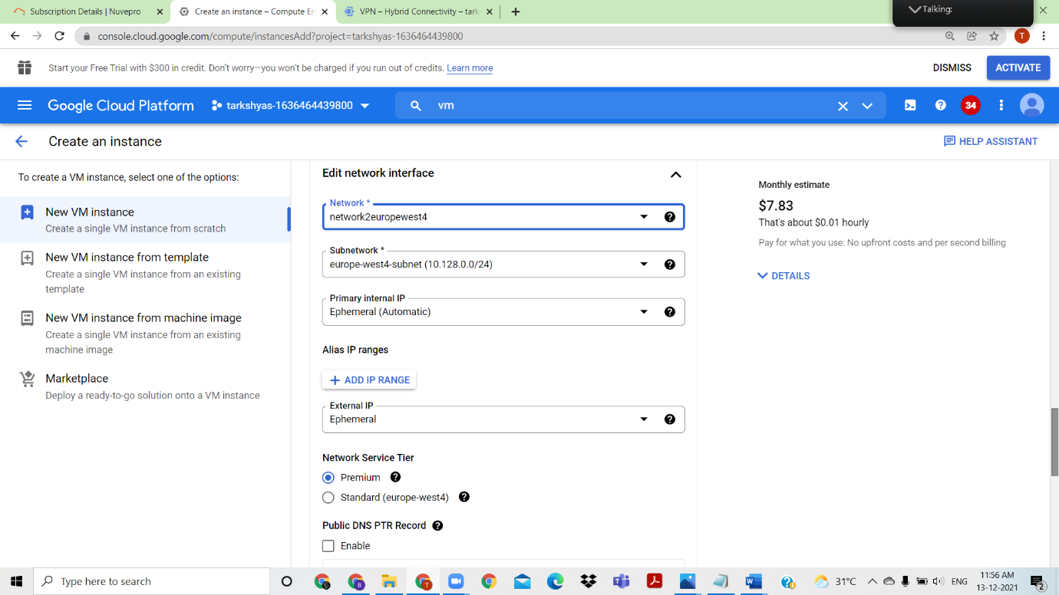

Create VM instance for Network 2 in Europe west4

In classic VPN, create a routing using the Dynamic BGP

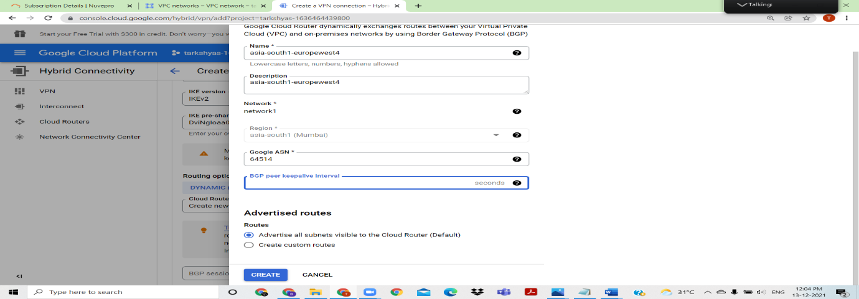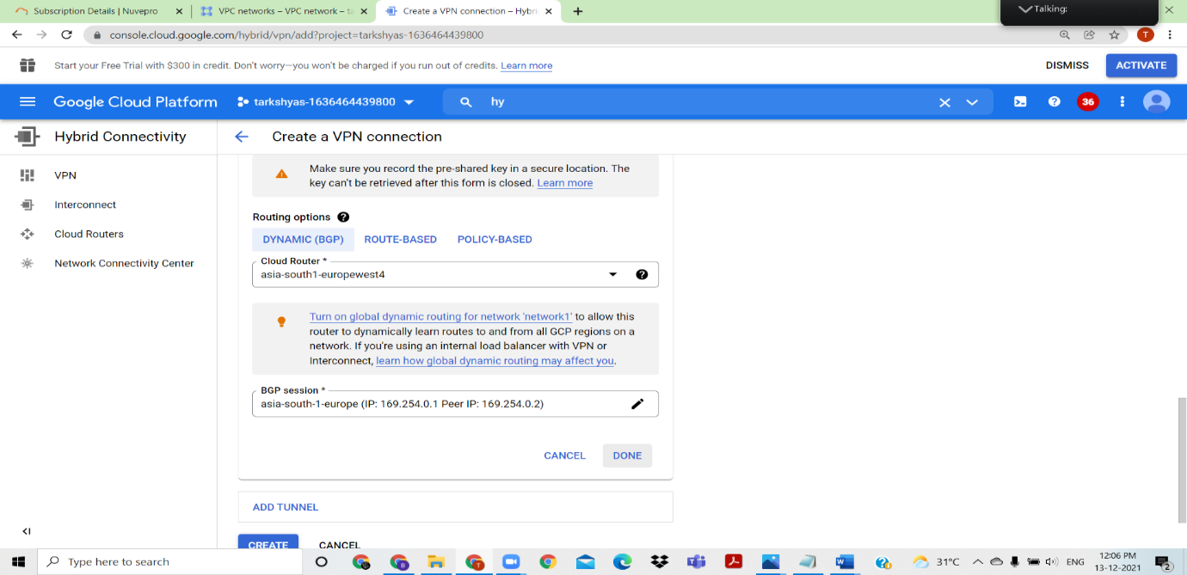  
VPN connection created between network1 and network2( Asiasouth1 to Europe west4)

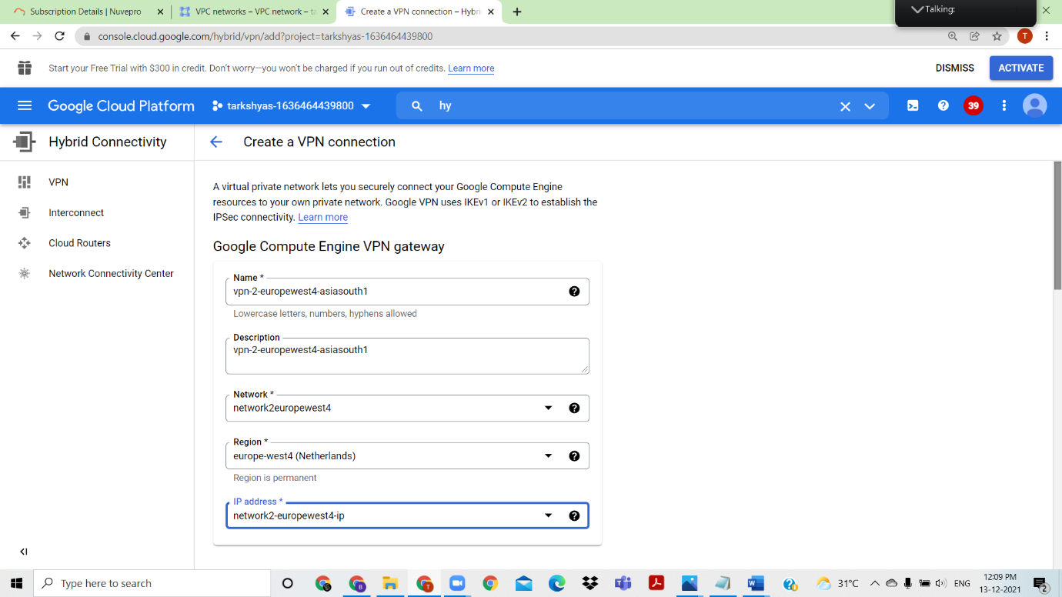

Create VPN connection between network2 and network1(Europewest4 to asiasouth1)

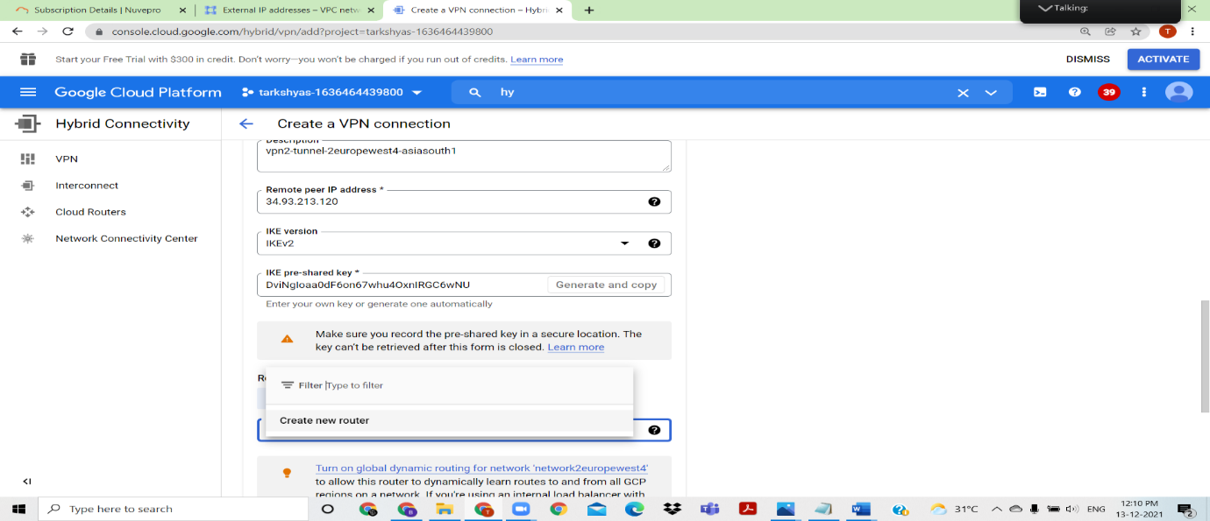

Create the vpn connection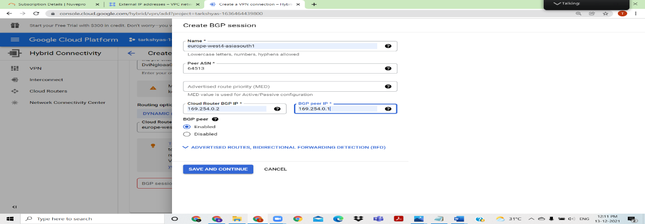

Created the dynamic BGP routing

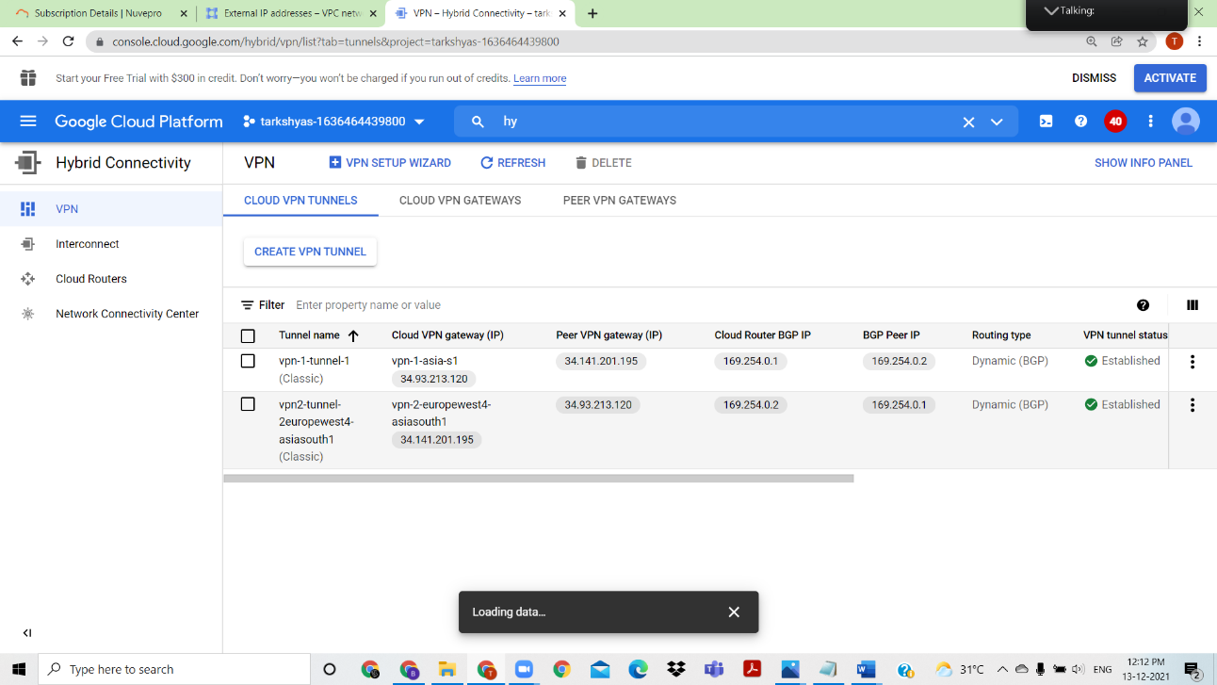

Connection established between the two networks

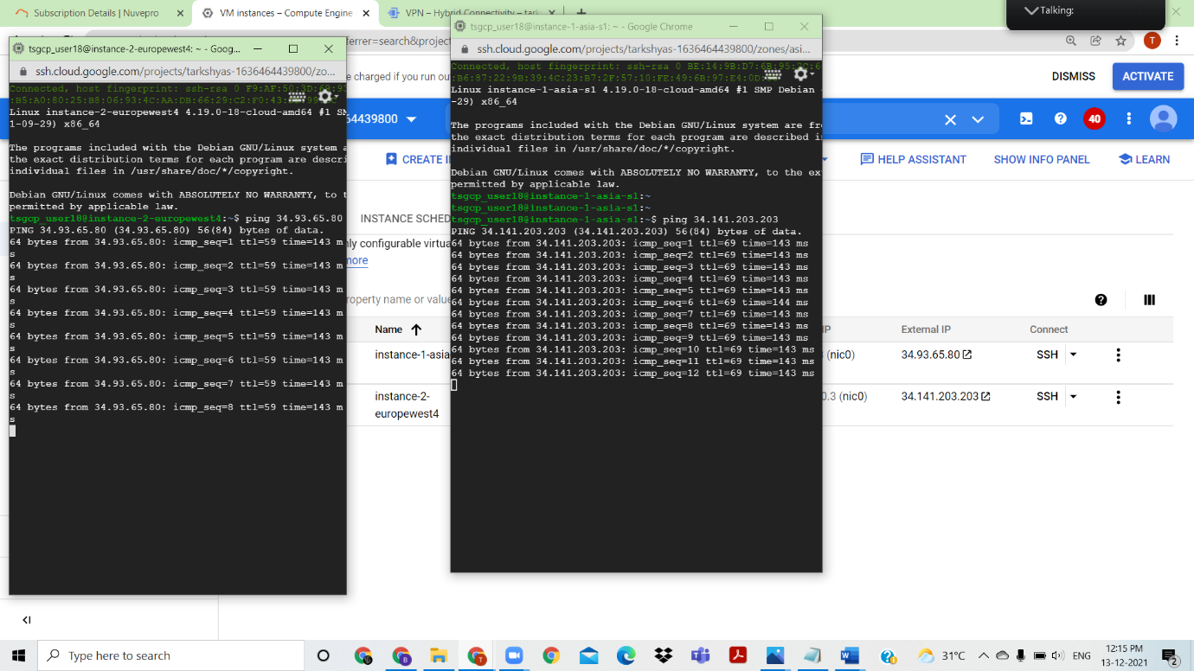

In VM instances ping between the two networks with ssh and its success.

QUESTION NO: 07 ) VPC peering

ANSWER:

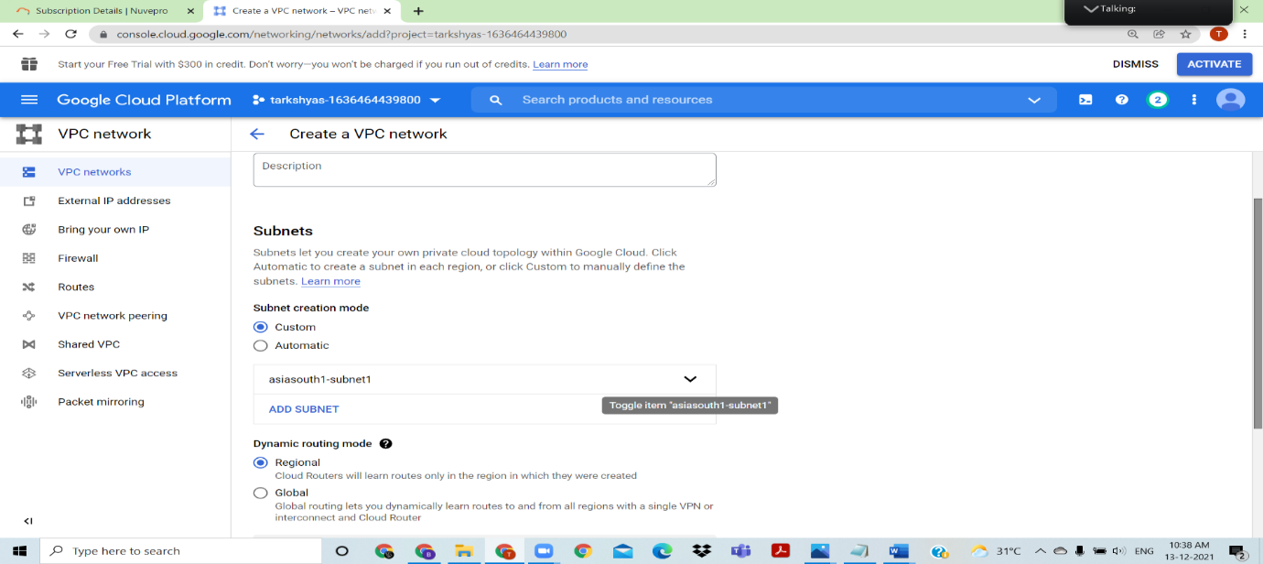

Create a vpc network1 and add subnet asiasouth1 to it

Create vpc network2 and add subnet europe west4

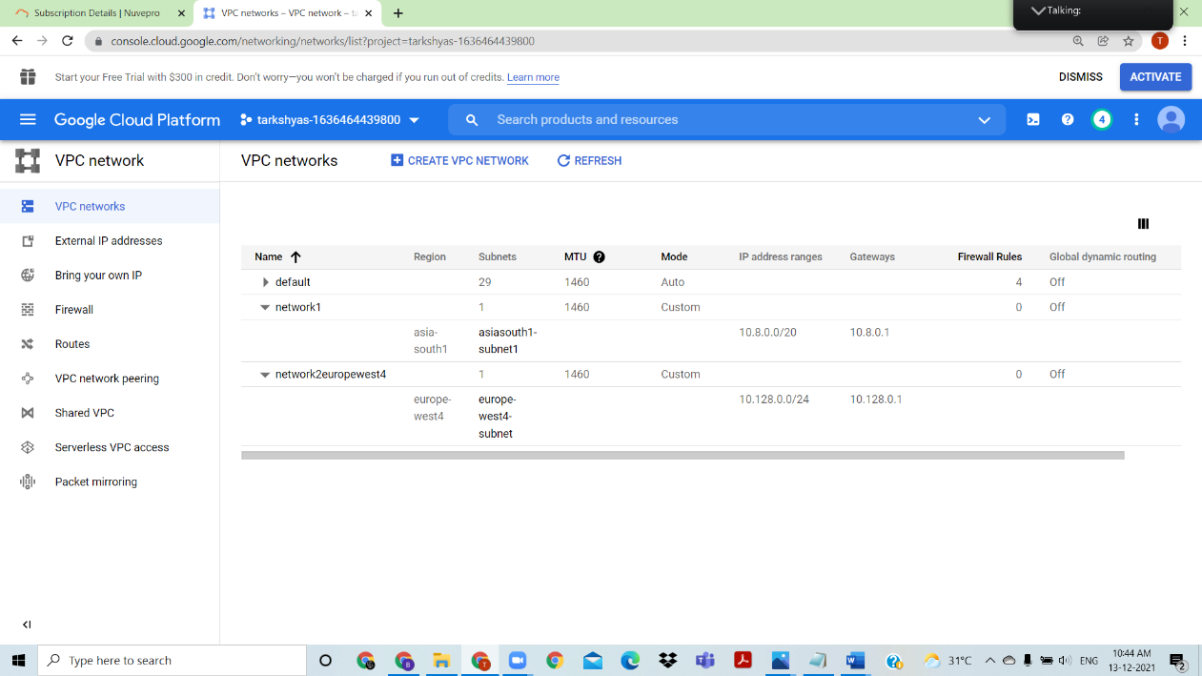

VPC Networks created at different locations

Create firewall for both network1 and network2

Firewall created 

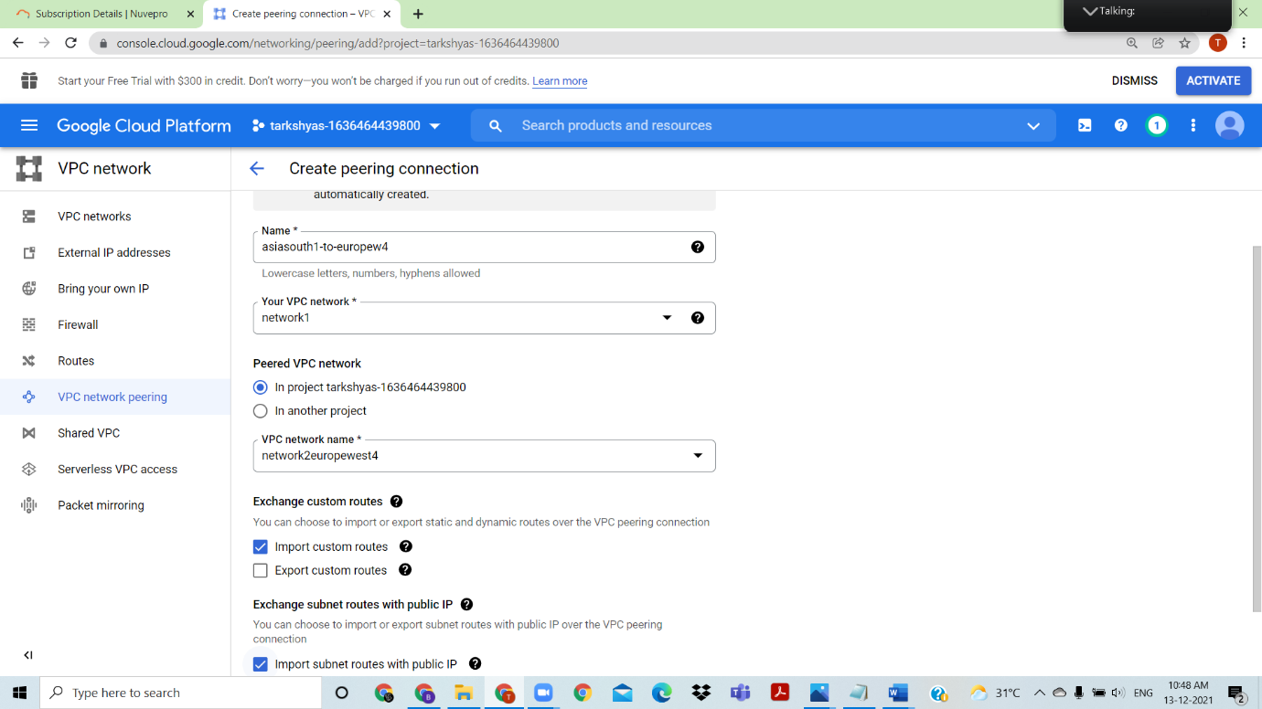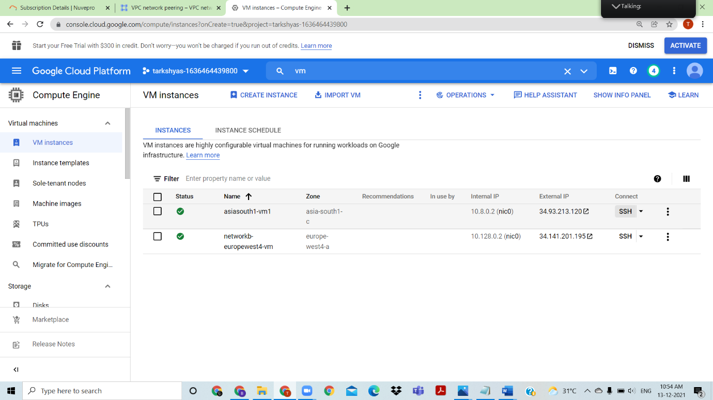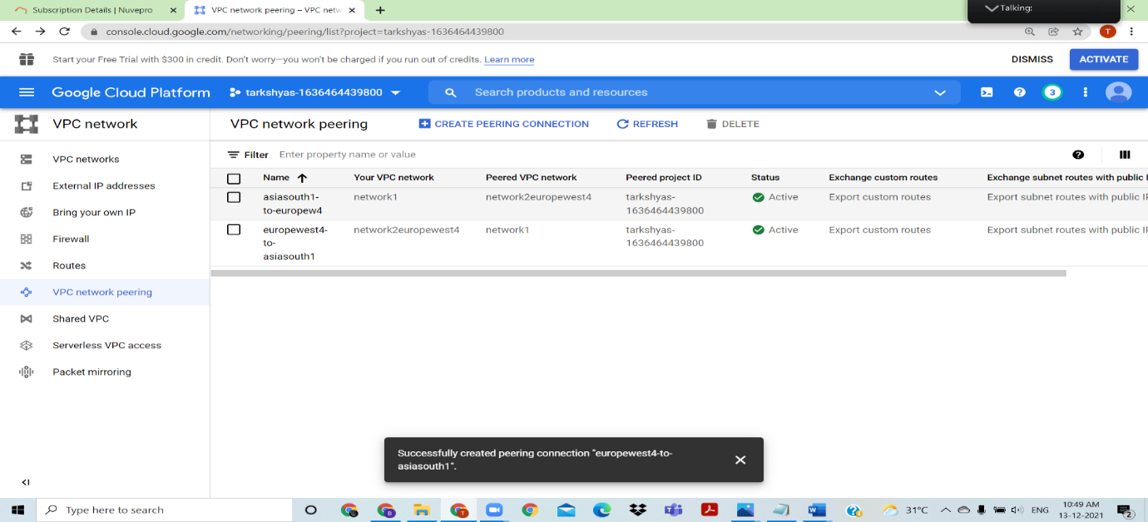

Created firewall

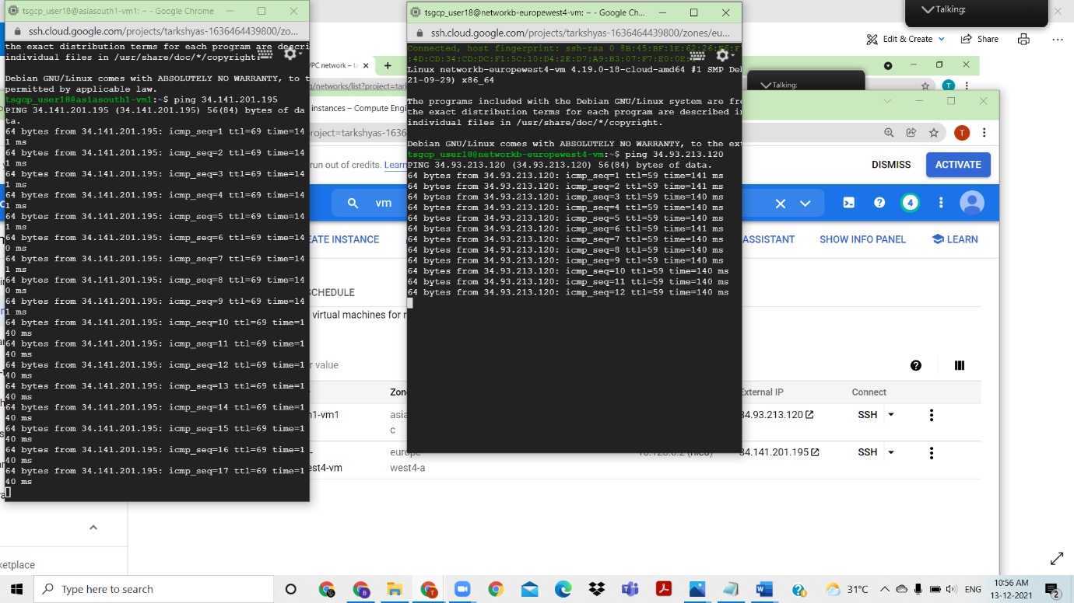Create a VM instance for network1 with subnet asiasouth1 ,Create vm instance for network2

After creating both Vm instances , ping between two using the external ip of asia to ping with Europe and use external ip of europe to ping with vm in asiasouth1

Ping success

QUESTION NO- 10

10)Google Kubernetes Engine

ANSWER:

Enable Kubernetes API and create a Kubernetes cluster

Choose GKE standard 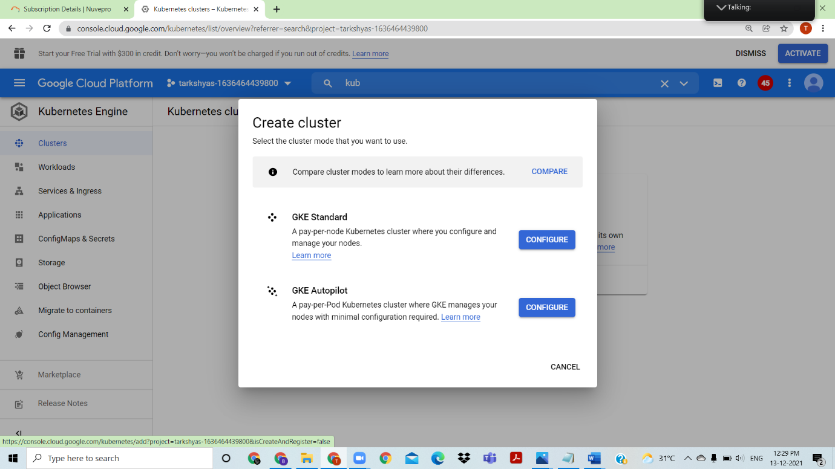

Open the cloud shell and docker run -d -p 8080:80 nginx:latest

Git clone with github

<https://github.com/learning-zone/website-templates>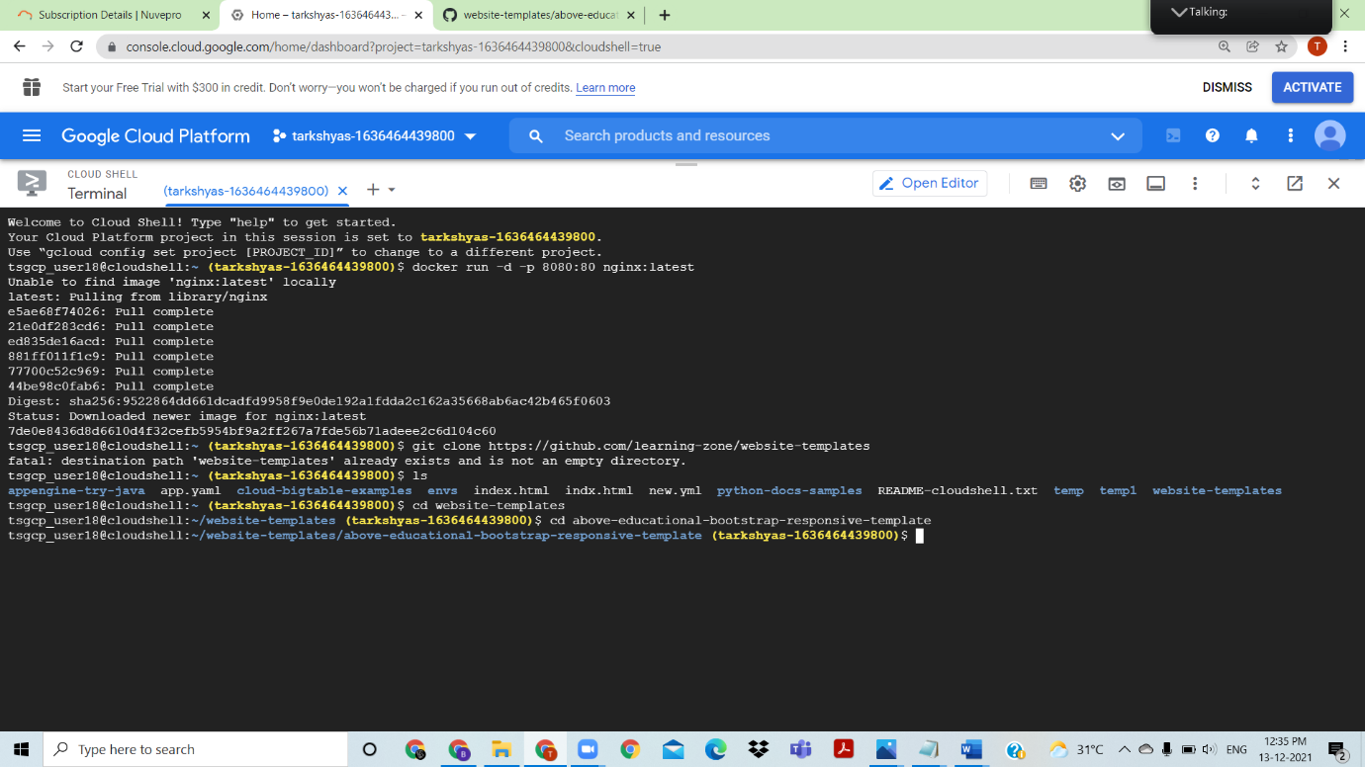

<https://github.com/learning-zone/website-templates/tree/master/above-educational-bootstrap-responsive-template>

using this multipage webpage is deployed using Kubernetes

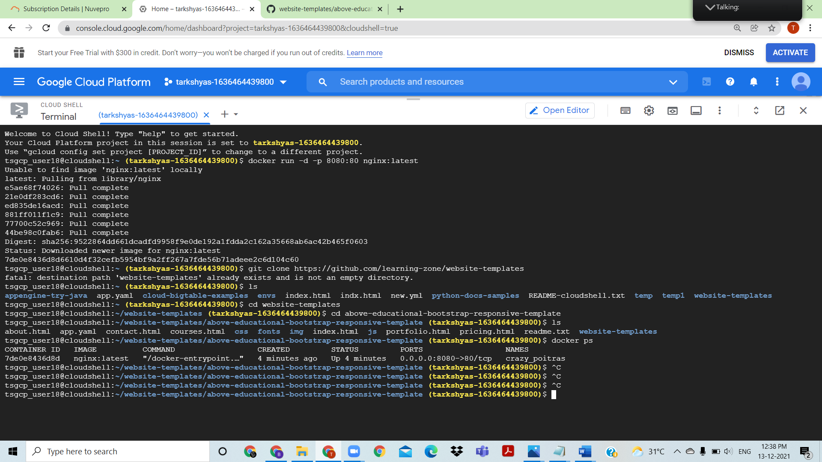

Docker ps gives the container id, copy that and use for docker cp

Perform tag and push , and authorize cloud shell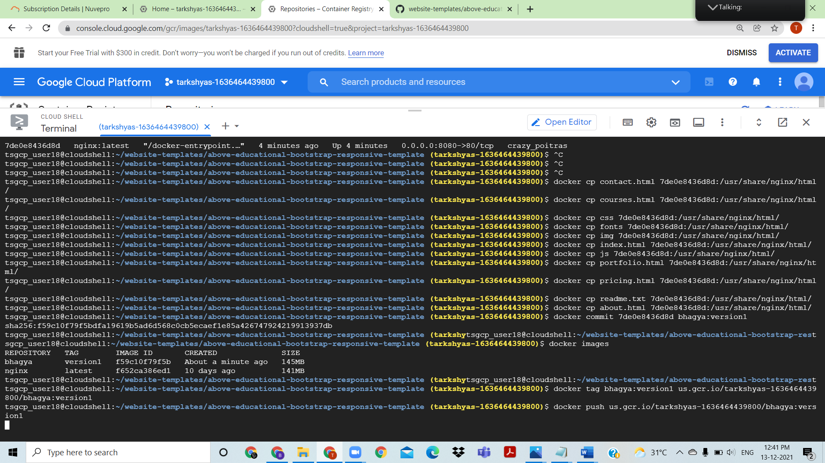

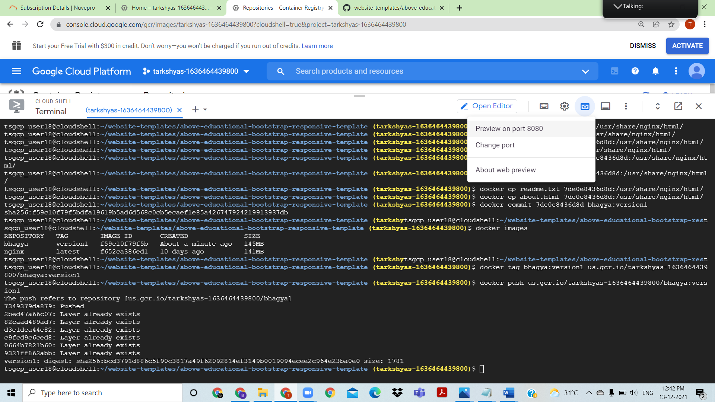

View the web preview on port 8080

Create a Kubernetes Engine to deploy multipage website with an ip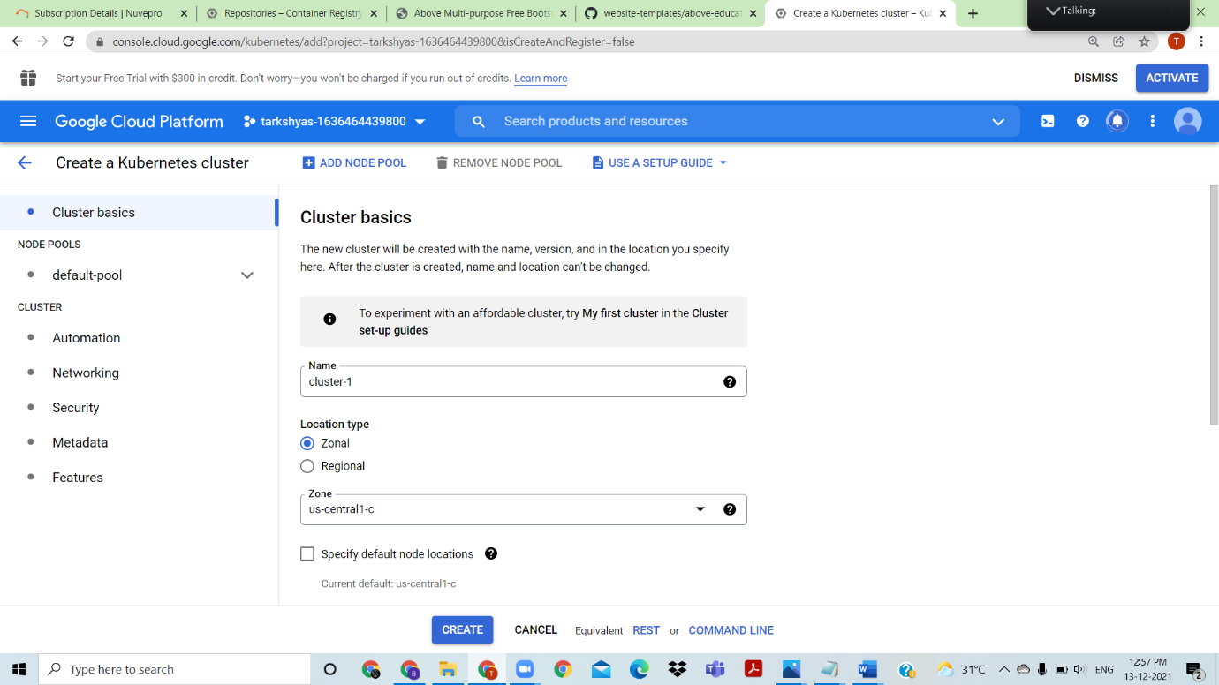

USE GKE standard to create kubernetes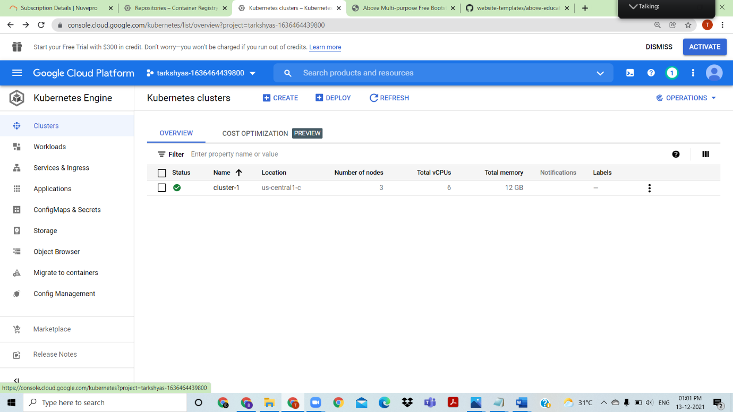

Created cluster at us central1

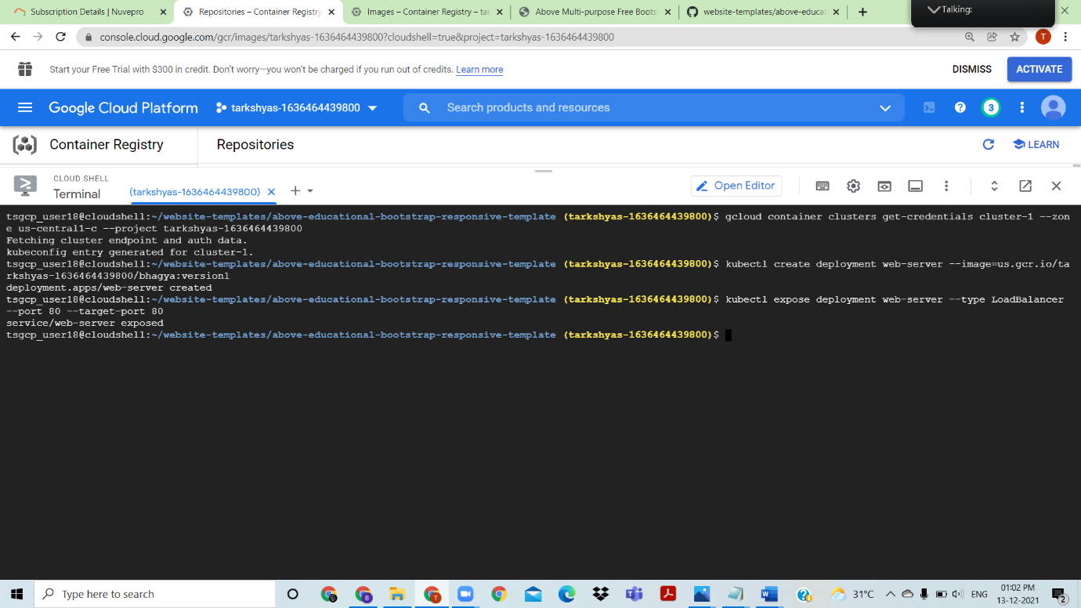

Create deployment and then outputs an external ip, search for that external ip shows the output 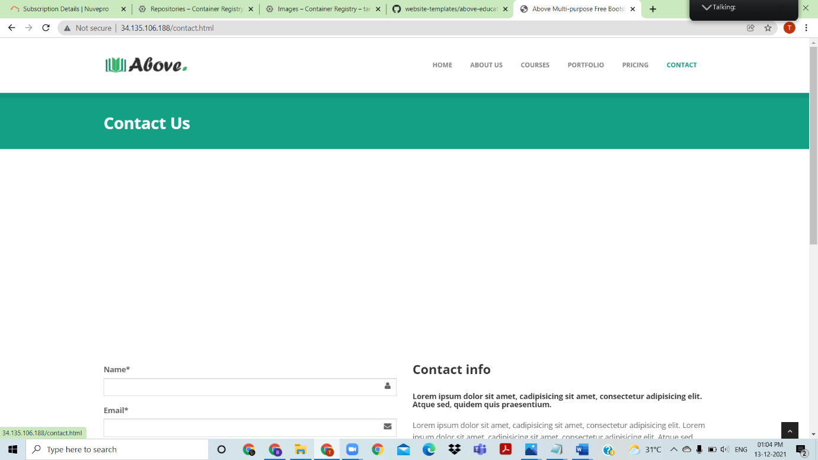

multipage webpage deployed using Kubernetes

QUESTION 8: Cloud DNS

Answer: enable cloud DNS API

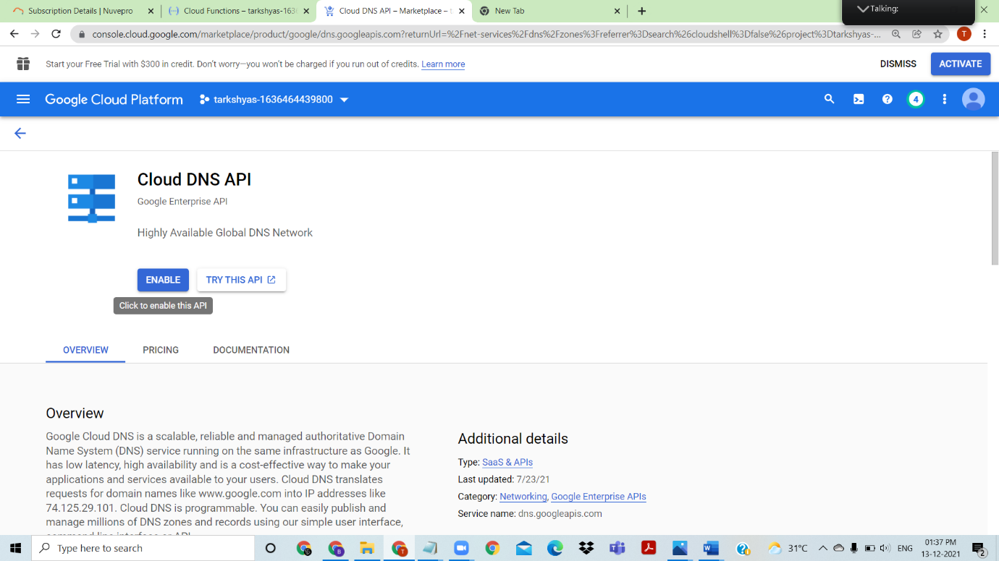

Freenom provides the free domain names ,and purchase i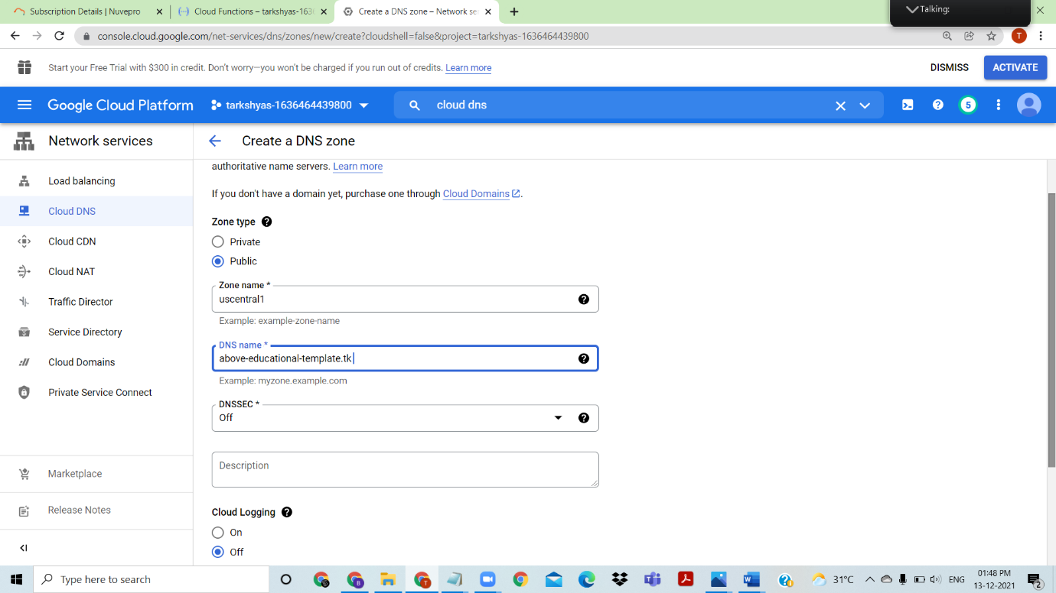t from freenom

Create a dns zone with dns name above-educational-template.tk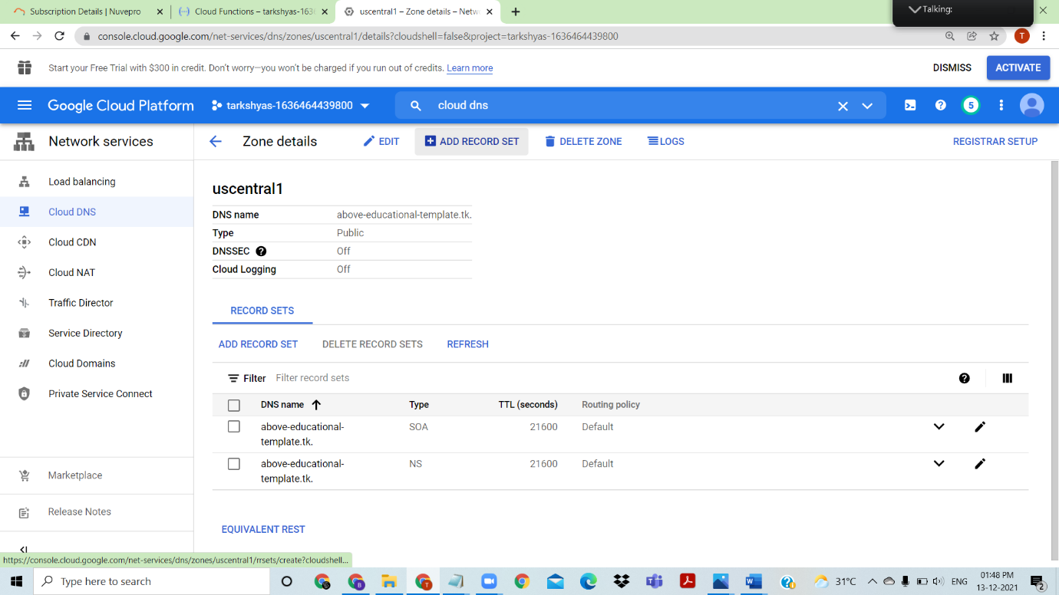

Add record sets

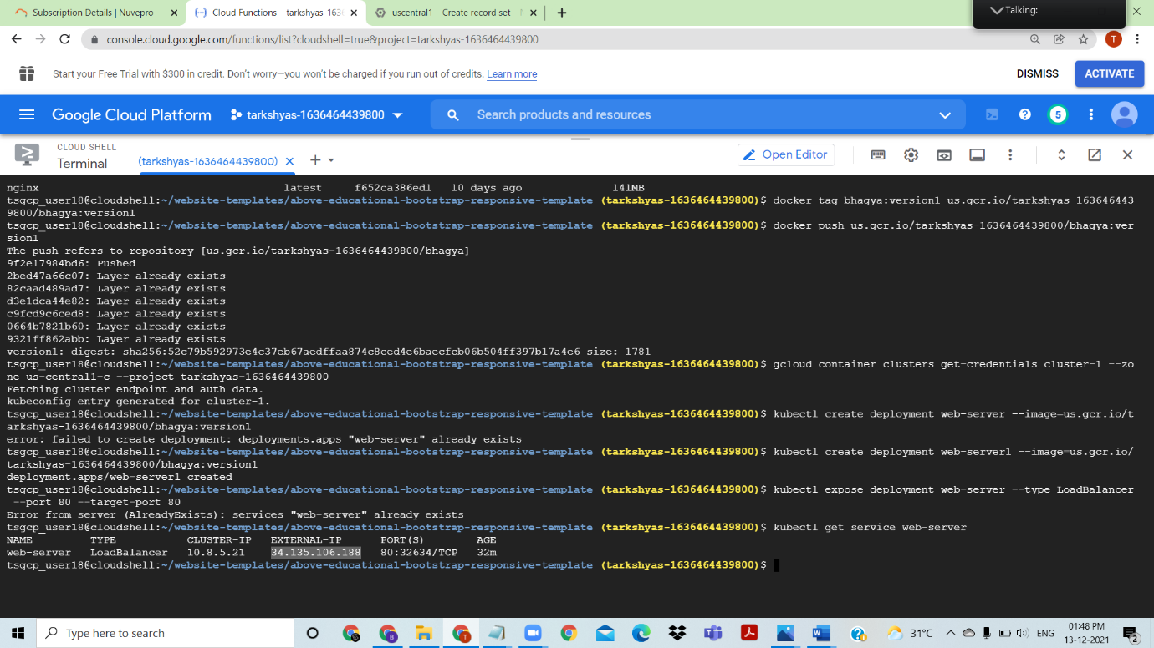

This output of cloud shell shows an external ip of multipage deployed using kubernetes, with this external ip of multipage shown below I am going to map the external ip with dns



The external ip which is taken from multipage website deployed using kubernetes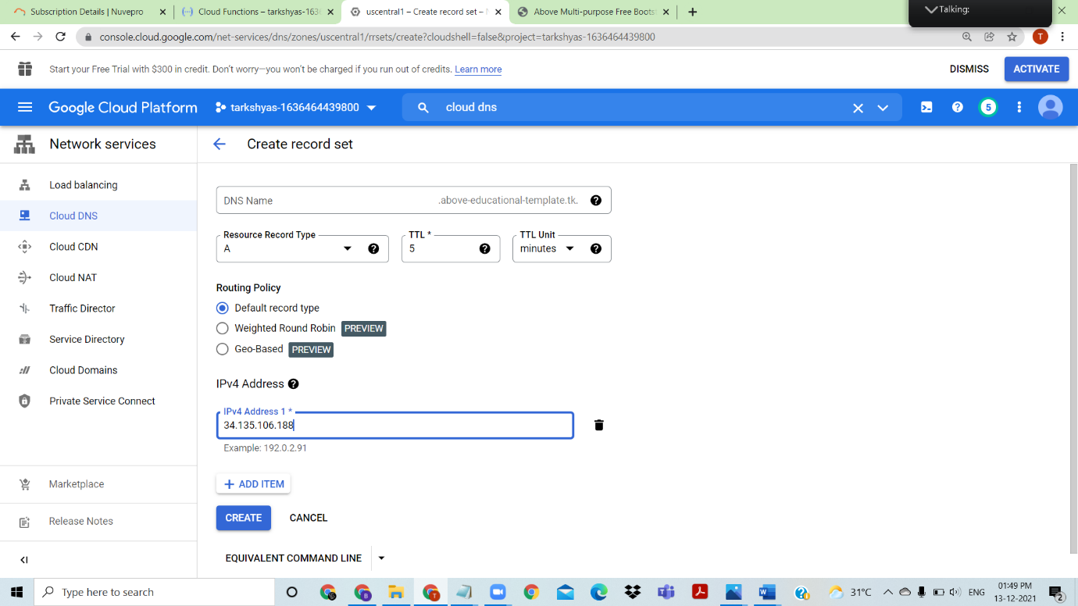

The external ip is provided here 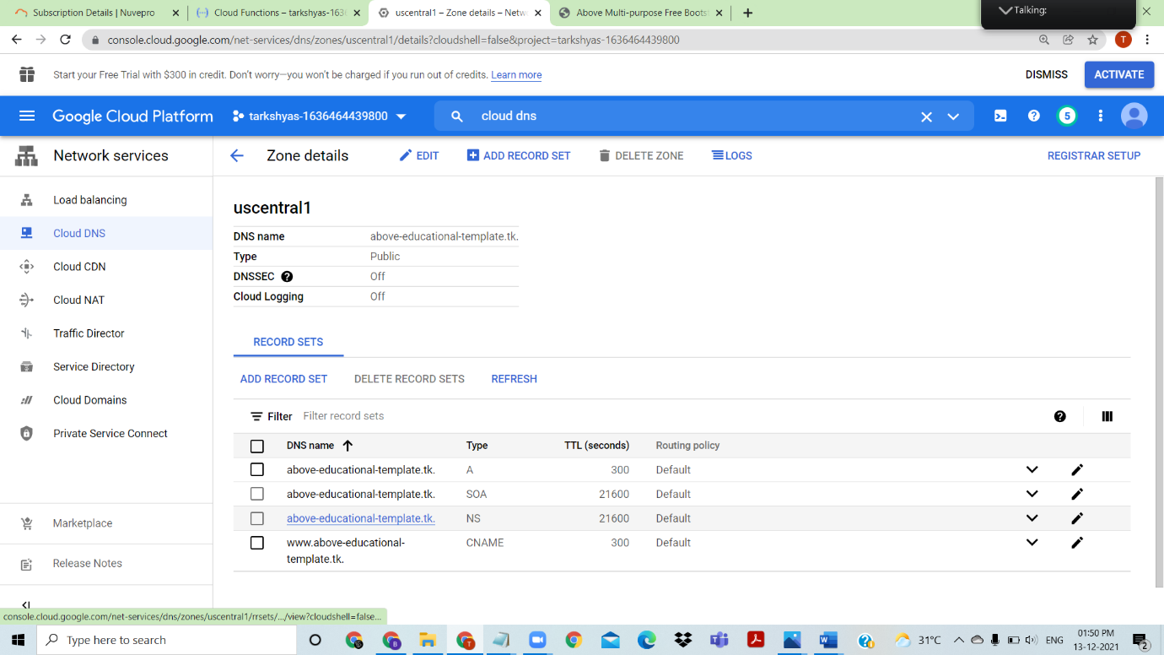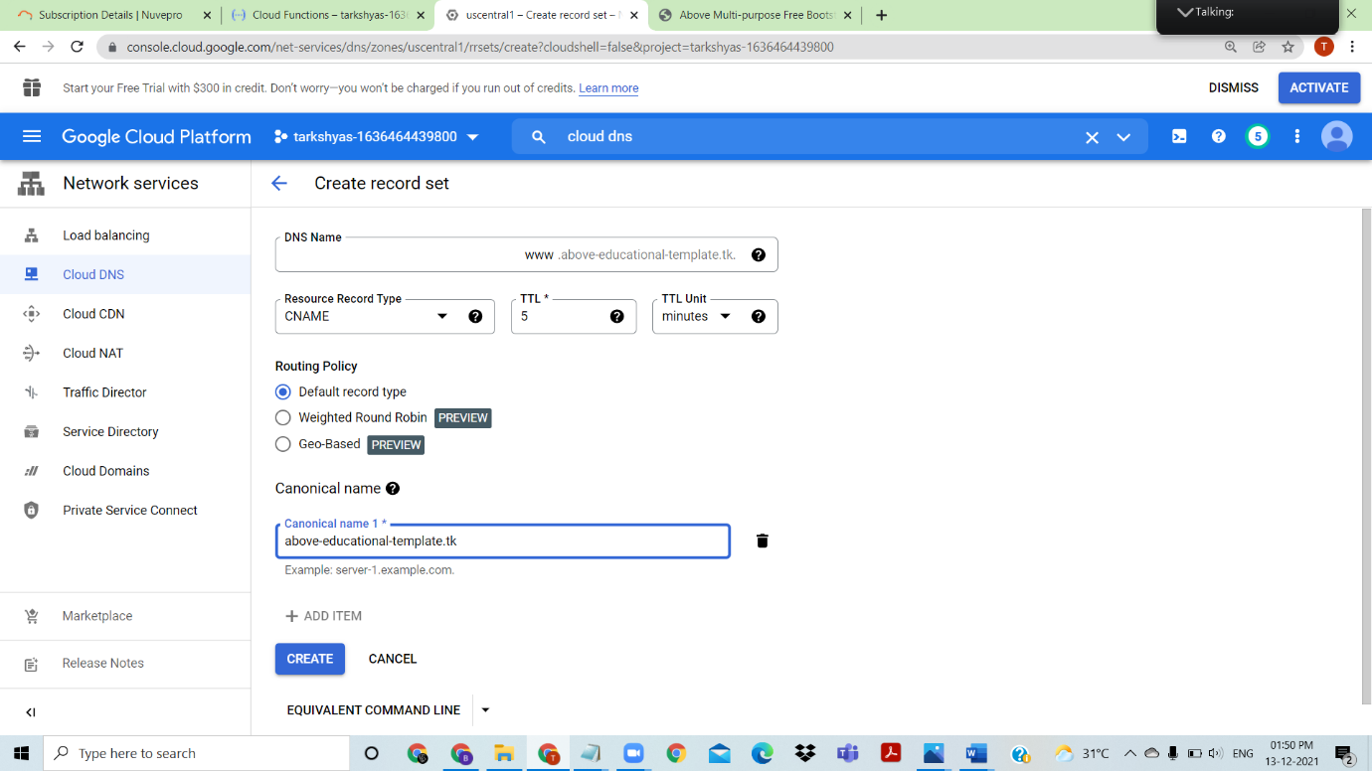

Create CNAME and A record sets

Go to freenom ----management tools---use custom nameservers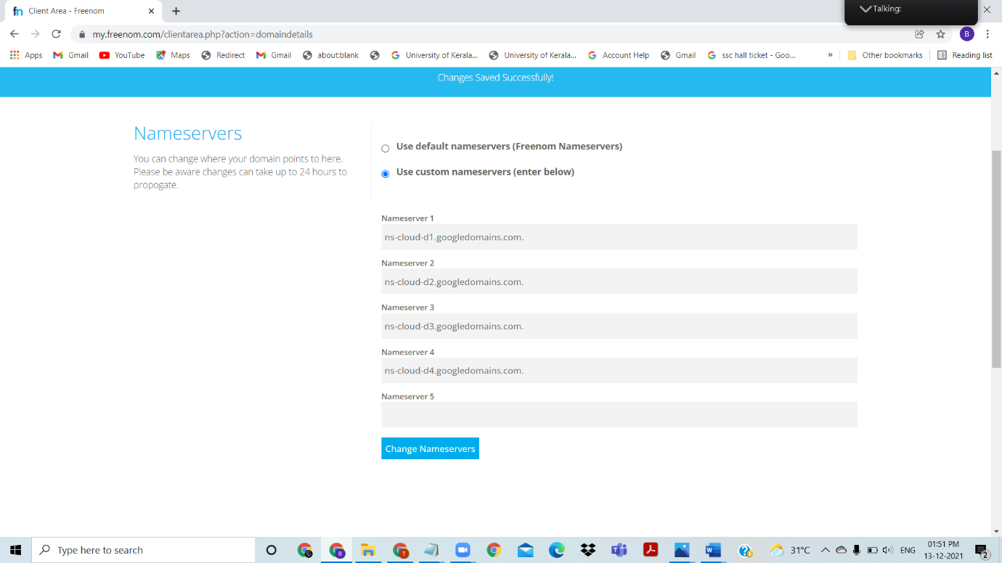

Fill all the required nameservers and then create.

Type that nameserver(above-educational-template.tk)/(www. above-educational-template.tk) to get the preview of webpage

Webpreview of the webpage using the dns

QUESTION 1: create a Linux VM and host a sample website given in below link

<https://github.com/learning-zone/website-templates/tree/master/above-educational-bootstrap-responsive-template>

ANSWER: 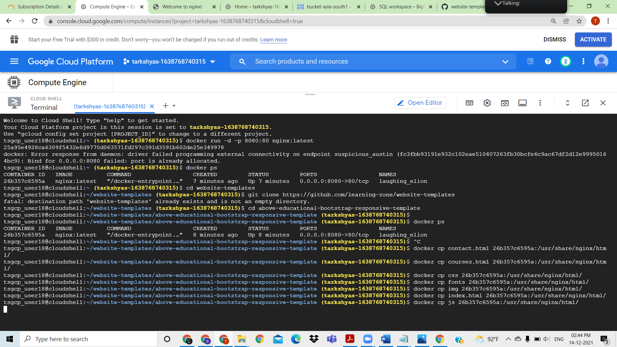

<https://github.com/learning-zone/website-templates/tree/master/above-educational-bootstrap-responsive-template>

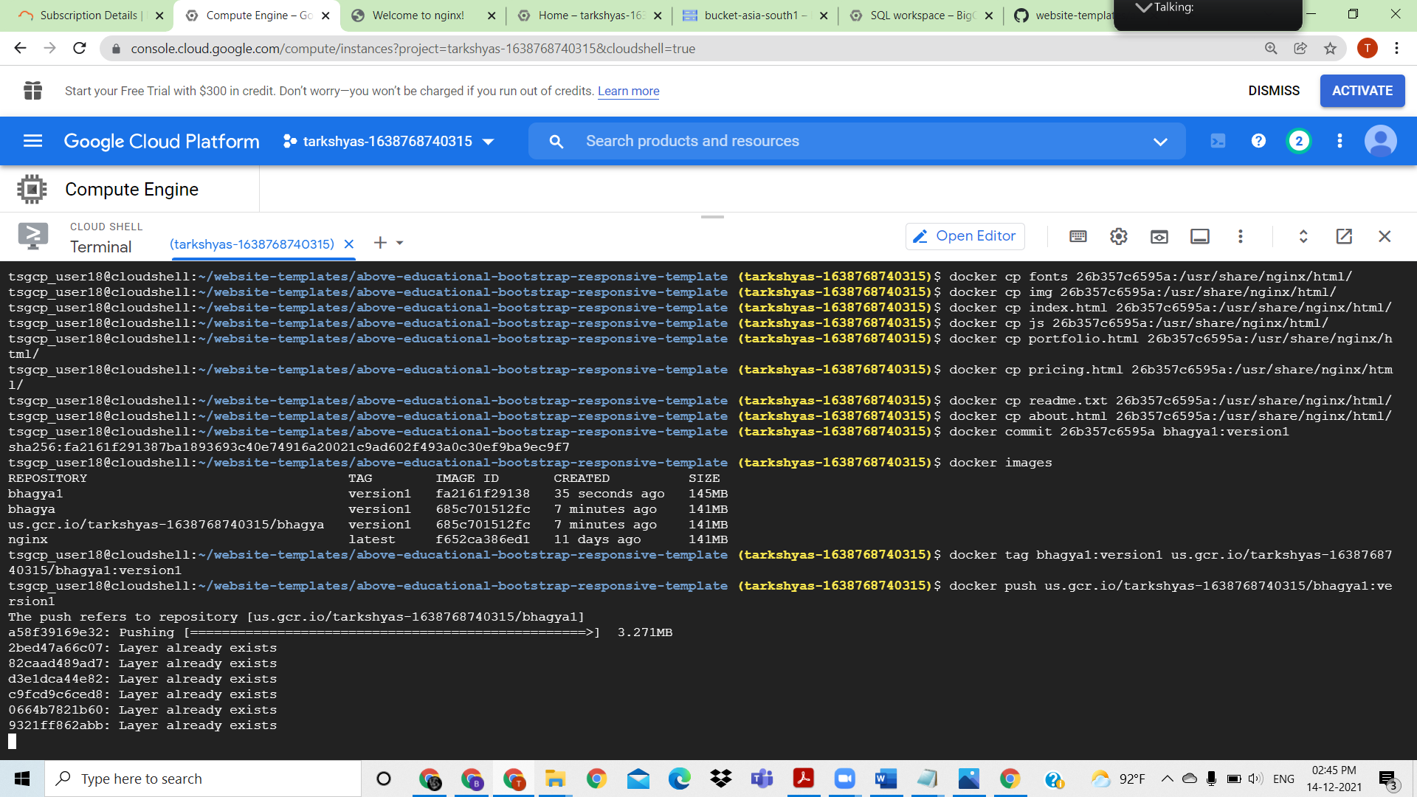

Create a docker container and push and tag into it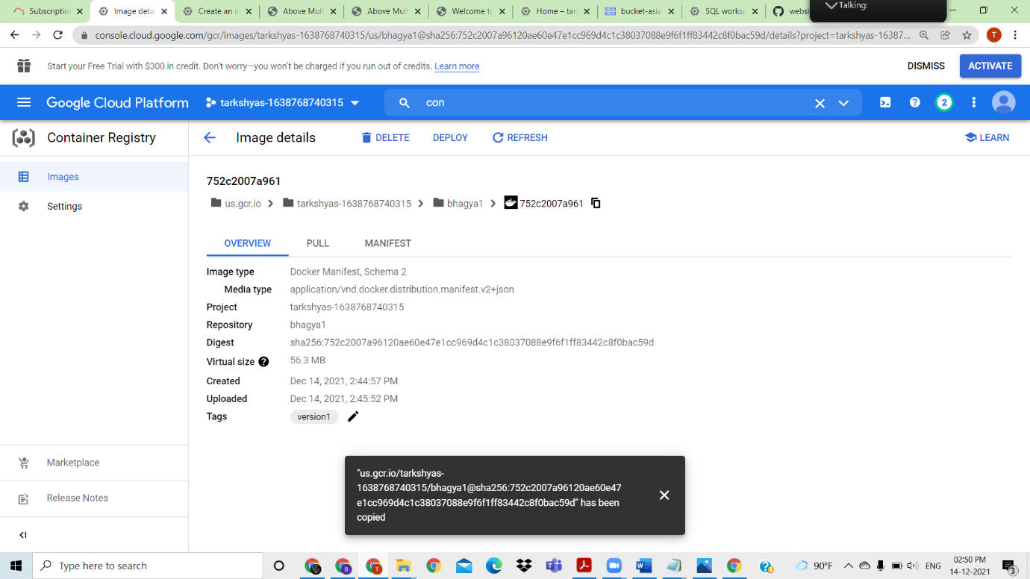

Go to container registry and copy the url for docker image created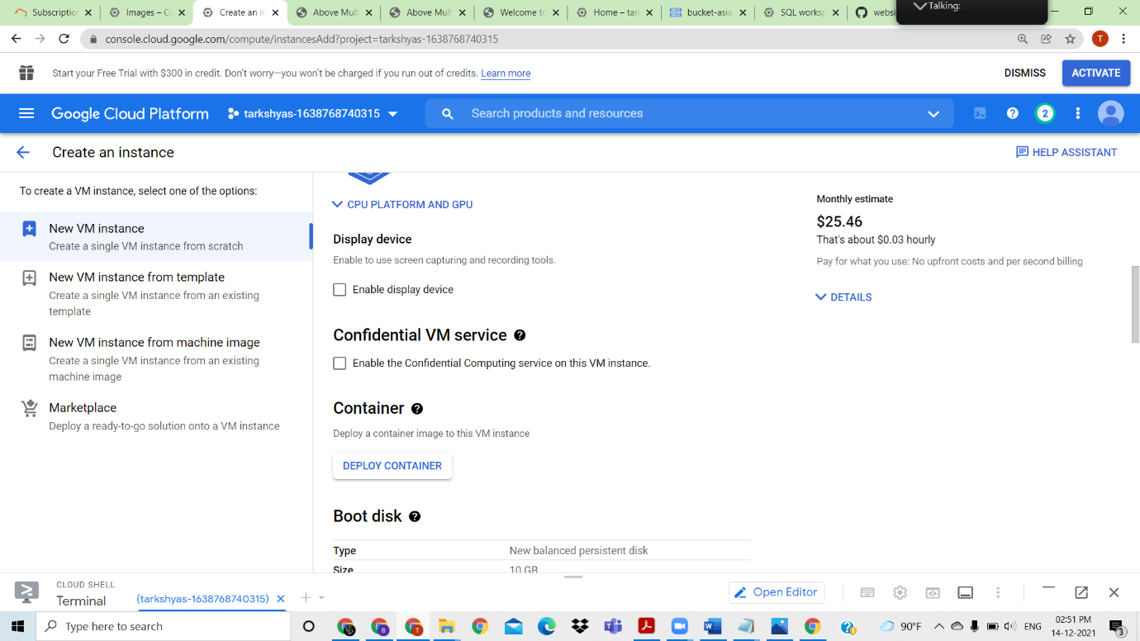

Create VM instance and add container to it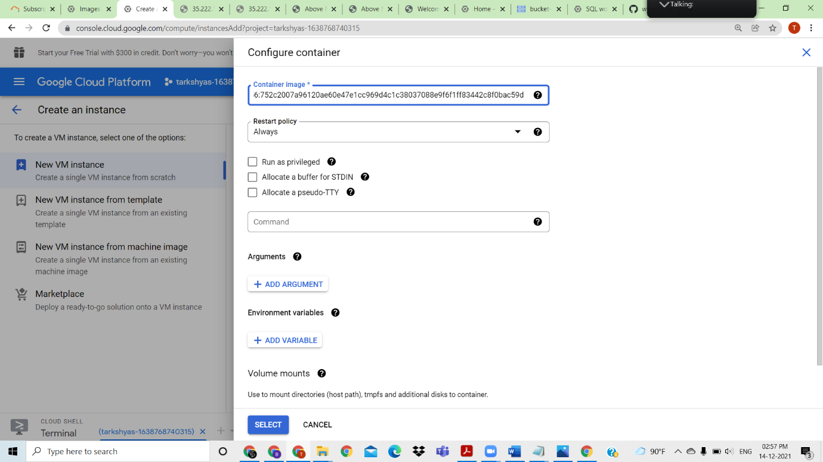

Paste the container image url and vm created, click on the external ip on VM instance to view webpage

created a Linux VM and host a sample website